PROXY SERVER CONFIGURATION (STEP-BY-STEP)

Purpose of Proxy Server
A proxy server:
- Acts as an intermediary between client and internet
- Can control, monitor, and cache web traffic

PART A: Ubuntu 1 (Proxy Server Setup)

Step 1: Install Squid Proxy
On Ubuntu 1 (192.168.153.128):
sudo apt update
sudo apt install squid –y
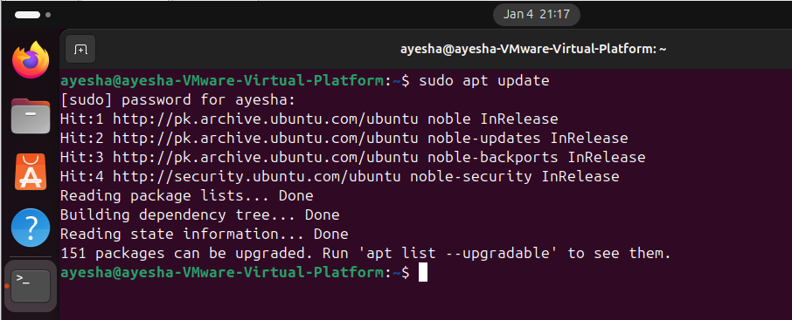

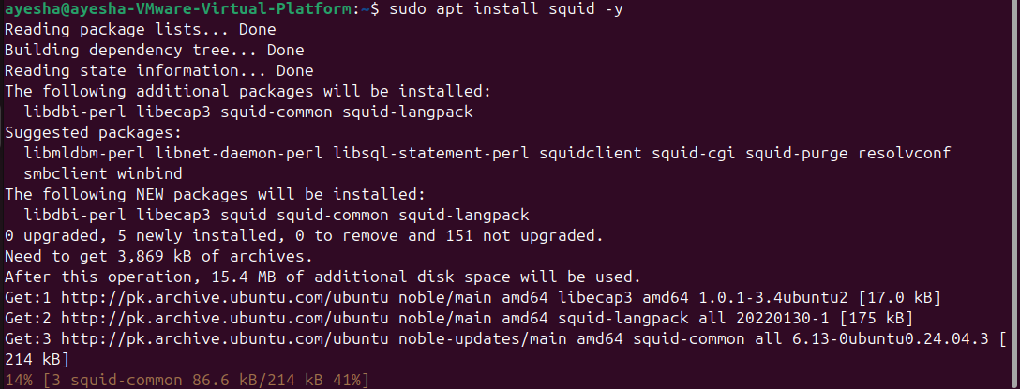
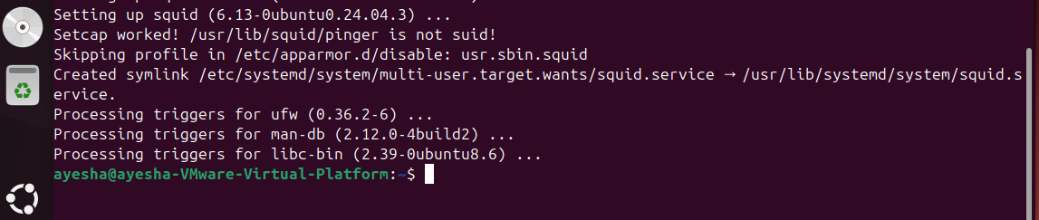

Step 2: Check Squid Service
sudo systemctl status squid
✔ Should show:
Active: active (running)
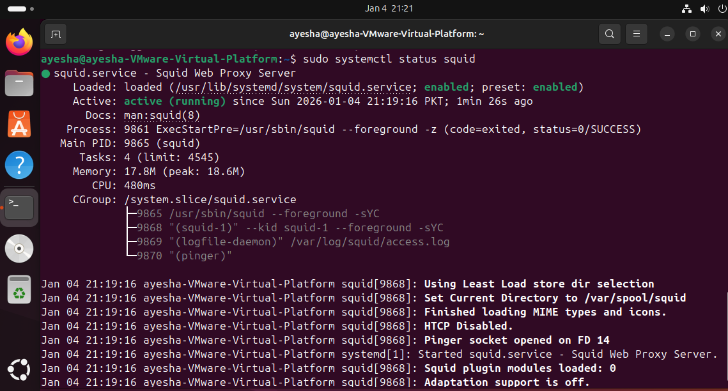

Step 3: Backup Squid Configuration (IMPORTANT)
sudo cp /etc/squid/squid.conf /etc/squid/squid.conf.backup

Step 4: Edit Squid Configuration
Open config file:
sudo nano /etc/squid/squid.conf

Required Configuration (Do ONLY These Changes)

1. Allow Local Network Access
Find: http_access deny all
Do NOT delete it
Before that line, add:
acl localnet src 192.168.157.0/24
http_access allow localnet

2. Set Proxy Port (Default 3128)
Make sure this line exists (usually already there):
http_port 3128

3. Set Visible Hostname (Optional but Good)
Add near bottom:
visible_hostname proxy-server

4. (Optional) Block One Website (For Demo / Viva)
Add at bottom:
acl blocked_sites dstdomain .facebook.com
http_access deny blocked_sites
This is optional but very good for demonstration.

Final Order (VERY IMPORTANT)
Make sure this order exists:
acl localnet src 192.168.157.0/24
http_access allow localnet
http_access deny blocked_sites
http_access deny all
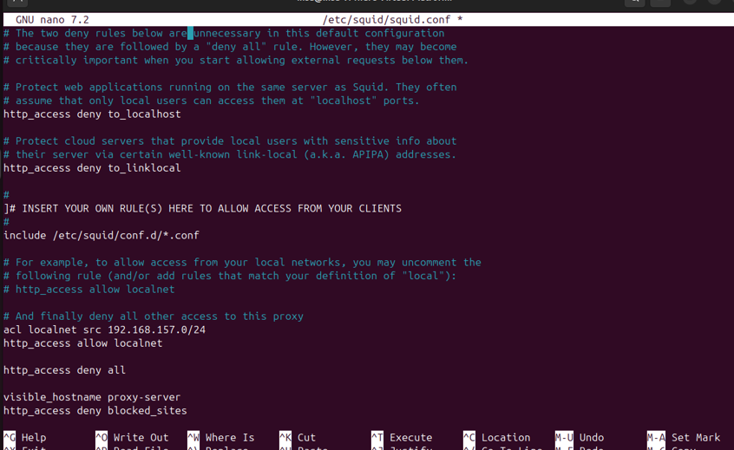.
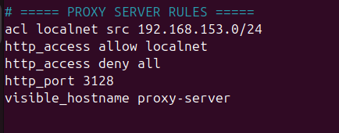

Step 5: Restart Squid
sudo systemctl restart squid
sudo systemctl status squid
✔ Must show active (running)
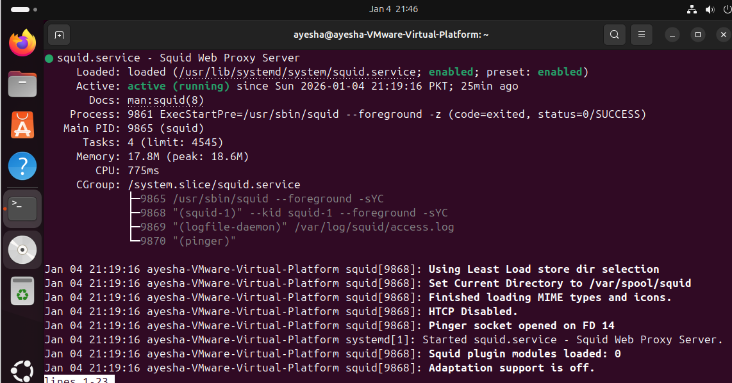

PART B: Ubuntu 2 (Client Proxy Configuration)

Step 6: Configure Proxy in Browser (Firefox)
- Open Firefox
- Settings → Network Settings
- Select Manual Proxy Configuration
- HTTP Proxy:
- 192.168.157.128
- Port:
- 3128
- Check “Use this proxy server for all protocols”
- Click OK

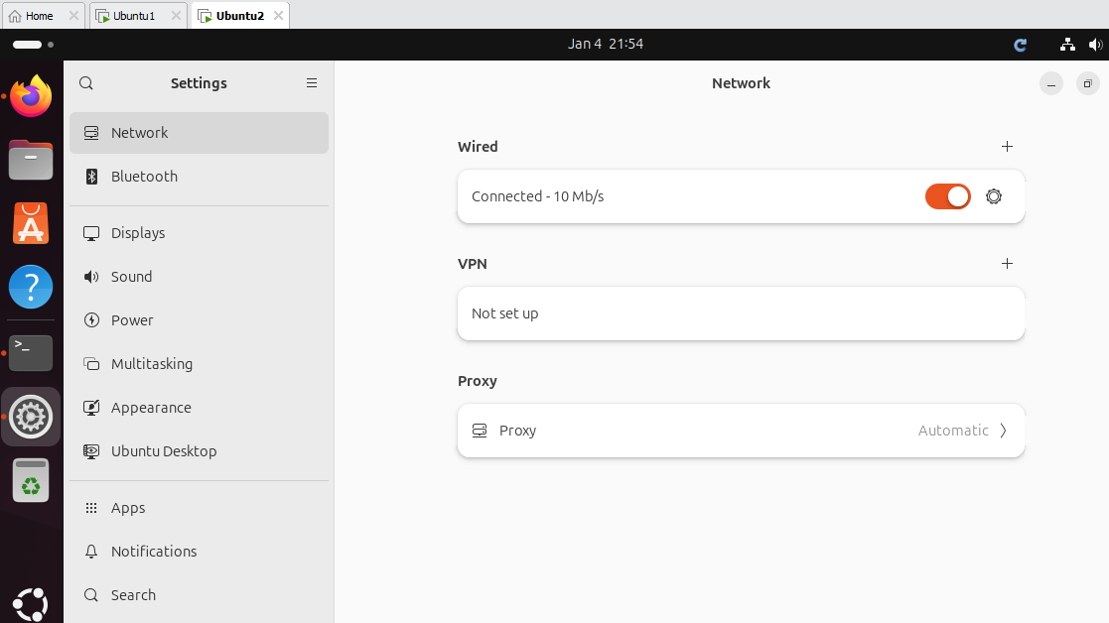
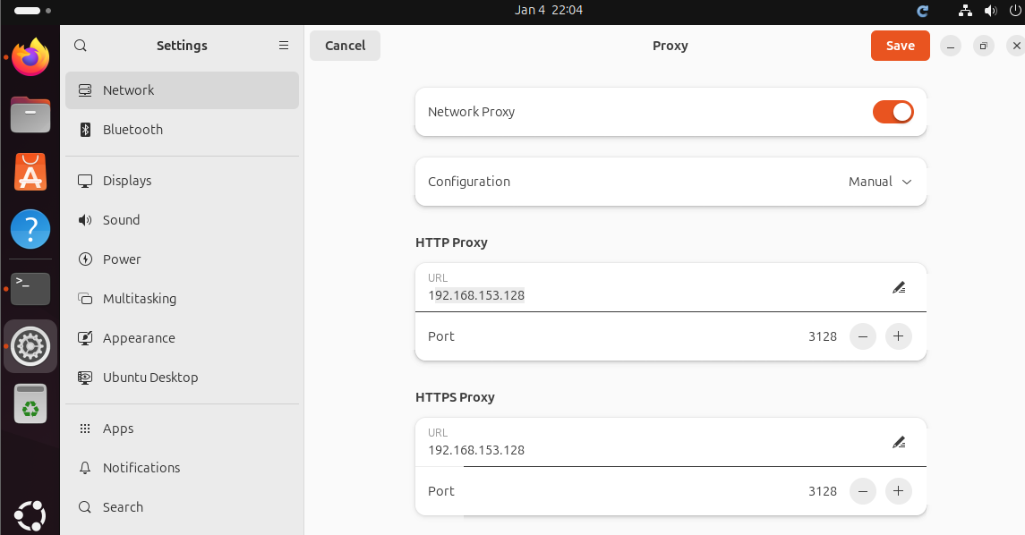

Step 7: Test Proxy

Test 1: Normal Website
Open:
http://google.com
✔ Page opens → proxy working
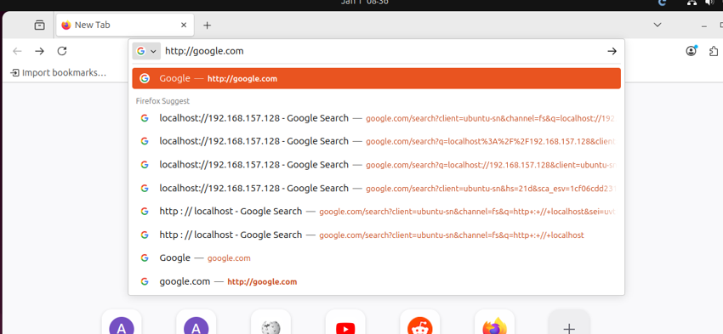
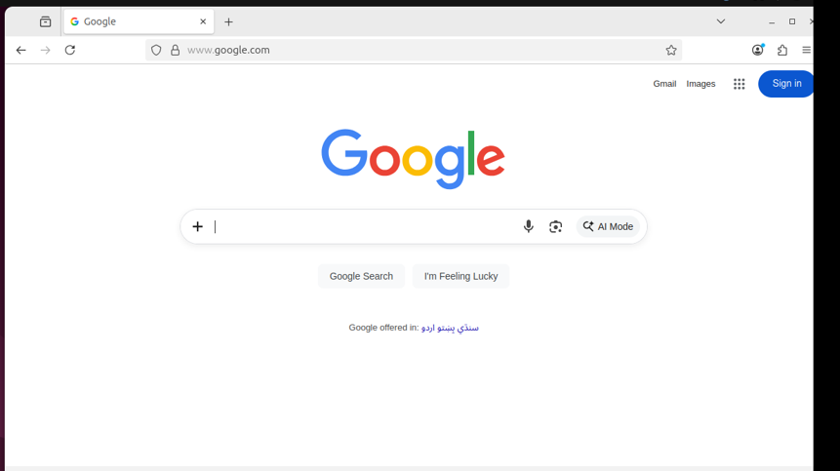

Test 2 (If you blocked Facebook)
Open:
http://facebook.com
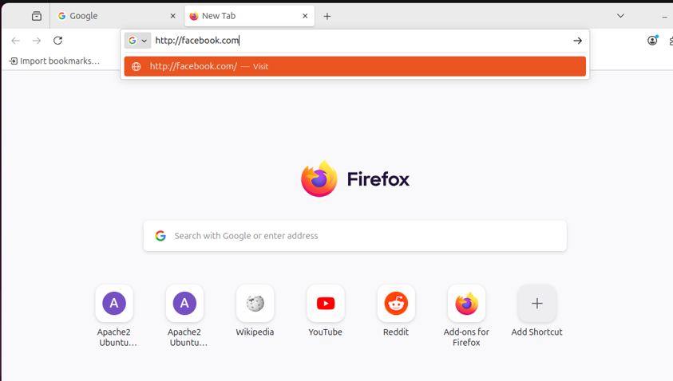
CONFIRMATION

On Ubuntu-1 (proxy server) :
sudo tail -f /var/log/squid/access.log

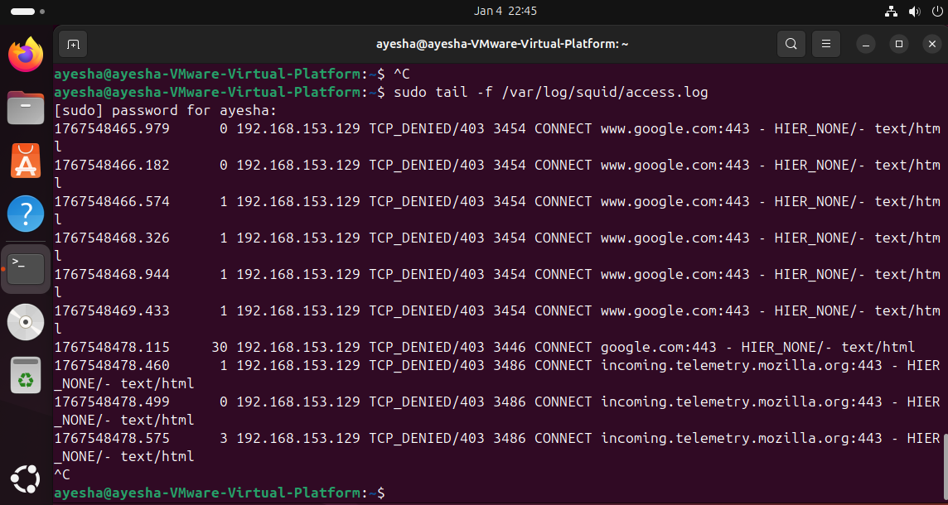

Ubuntu-2 (Firefox) :
http://neverssl.com
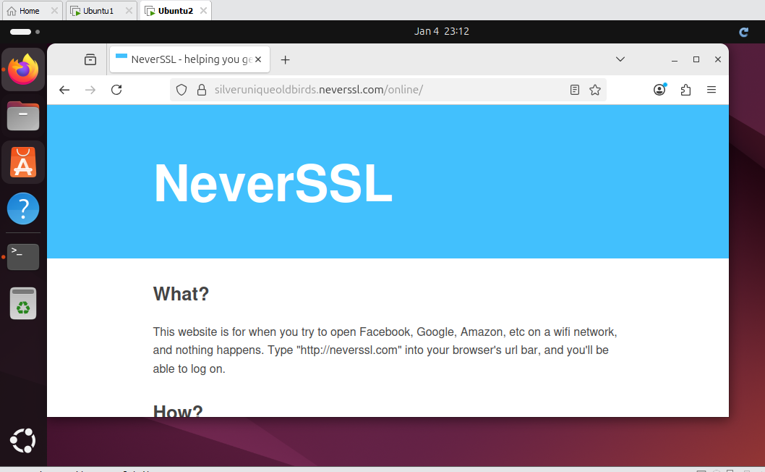

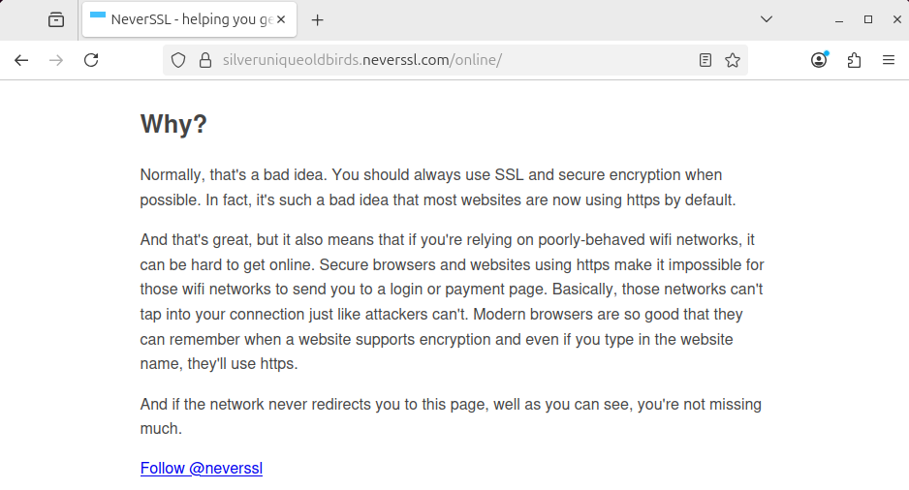

➡️ If Log→ Proxy FORCED & WORKING
Conclusion
A proxy server was configured on Ubuntu 1 using Squid. The proxy listens on port 3128 and allows clients from the local network to access the internet. Access control rules were applied to manage web traffic.
Squid proxy server was configured successfully.
Client traffic was verified using HTTP test site (neverssl.com).
Access logs confirmed proxy usage.
HTTPS websites such as Facebook remained accessible due to encryption without SSL bumping.

